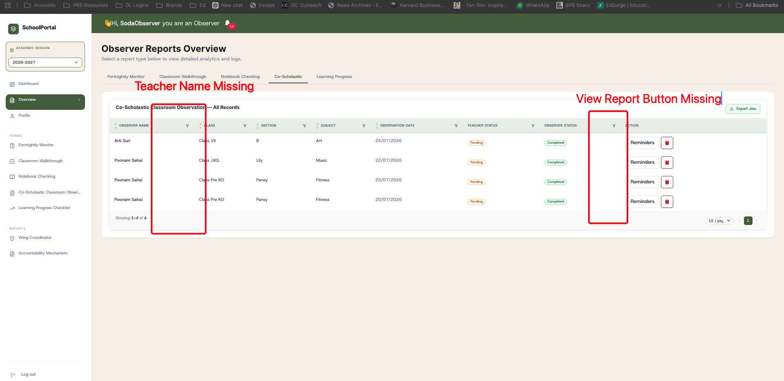

Suggestions and changes required in Wing coordinator Report
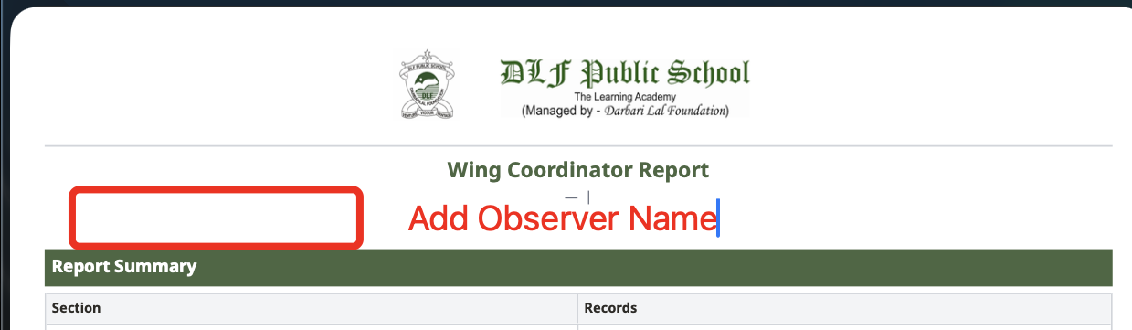
Add Creator Name and Form Name in the Report

Need a File Upload Button for Q6, Q7, Q9, Q11
Any File Uploaded should be automatically visible in the PDF Generated
Need a Select All button when filtering forms on Page 2
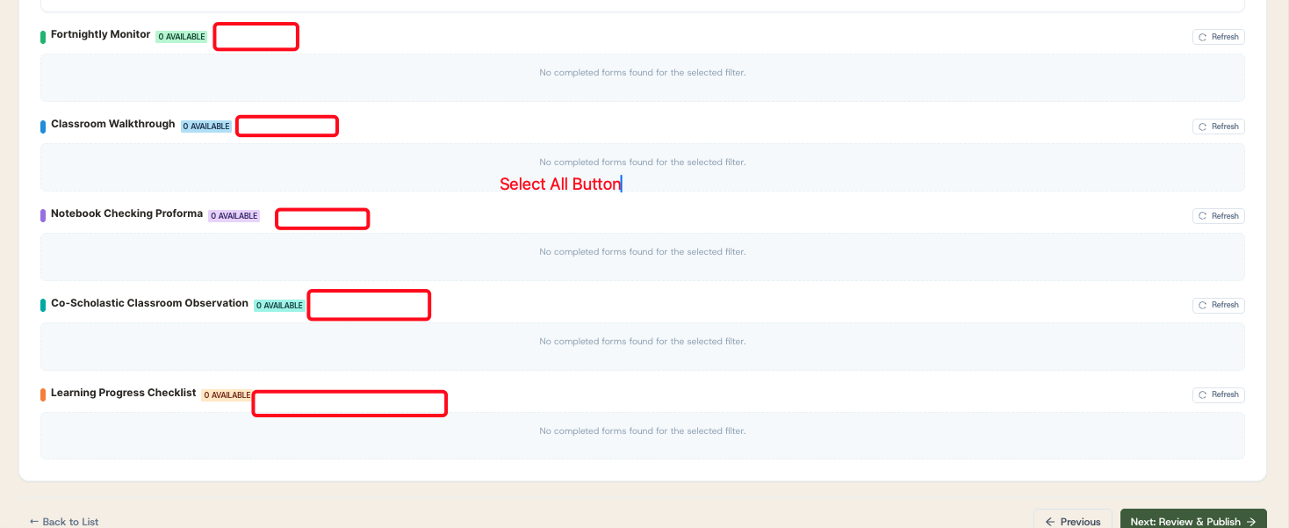
Whichever Question has Add Row Button, please add Auto S.No. COloumn for all of them
Header | Updation Required / Suggestions
Morning Assembly | - Add “Any Reward?” column
I C.A.R.E certificates of the month | Add columns “Student Name” “Class” “Whether posted on edunext”
Key outcomes of result discussion | Create columns
  Concern subjects and class | High achiever Subjects and class | Any smilye awarded to class | Any smilye awarded to teacher
Identify Learners on the way | Add column “Action plan” in each row  Add column “Strength of child” in each row
C.W.S.N names and progress | Add column “Half yearly progress”
Parent Meetings | Add column “Outcome of meeting” in each row.
Detention arranged | Change Question Name to “Detention arranged/ Extra input classes”  And add column “Outcome” in each row.  Add “Detention/extra input class?” in each row.
Care call made | Add column of “Outcome” in each row.

Add new Questions
1. Class and Subject work status (Add after Questions 13)
date | class | Name of student | subject | Status of work | Status of checking | Feedback/Action plan
Add row option
Excursions planned (Add after Questions 13)
S.no | Date of excursion | class | venue | Teachers accompany | Feedback/concerns
Add row option

